# Exercise 2: USING AMQ MANAGEMENT CONSOLE

## CONFIGURING LOCAL AND REMOTE ACCESS TO AMQ MANAGEMENT CONSOLE

Procedure

1. Open the ***<broker_instance_dir>*/etc/bootstrap.xml** file.
2. Within the **web** element, observe that the web port is bound only to **localhost** by default.

**<web path="web">**

**<binding uri="http://localhost:8161">**

**<app url="redhat-branding" war="redhat-branding.war"/>**

**<app url="artemis-plugin" war="artemis-plugin.war"/>**

**<app url="dispatch-hawtio-console" war="dispatch-hawtio-console.war"/>**

**<app url="console" war="console.war"/>**

**</binding>**

**</web>**

1. To enable connection to the console for the local broker from a remote host, change the web port binding to a network-reachable interface. For example:

**<web path="web">**

**<binding uri="http://0.0.0.0:8161">**

In the preceding example, by specifying **0.0.0.0**, you bind the web port to all interfaces on the local broker.

1. Save the **bootstrap.xml** file.
2. Open the ***<broker_instance_dir>*/etc/jolokia-access.xml** file.
3. Within the **<cors>** (that is, *Cross-Origin Resource Sharing* ) element, add an **allow-origin** entry for each HTTP origin request header that you want to allow to access the console.

For example:

**<cors>**

**<allow-origin>*://localhost*</allow-origin>**

**<allow-origin>*://192.168.0.49*</allow-origin>**

**<allow-origin>*://192.168.0.51*</allow-origin>**

<!-- Check for the proper origin on the server side, too -->

**<strict-checking/>**

**</cors>**

In the preceding configuration, you specify that the following connections are allowed:

Connection from the local host (that is, the host machine for your local broker instance) to the console.

The first asterisk (**\***) wildcard character allows either the **http** or **https** scheme to be specified in the connection request, based on whether you have configured the console for secure connections.

The second asterisk wildcard character allows any port on the host machine to be used for the connection.

Connection from a remote host to the console for the local broker, using the externally- reachable IP address of the local broker. In this case, the externally-reachable IP address of the local broker is **192.168.0.49**.

 Connection from within a console session opened on another, remote broker to the local broker. In this case, the IP address of the remote broker is **192.168.0.51**.

1. Save the **jolokia-access.xml** file.
2. Open the ***<broker_instance_dir>*/etc/artemis.profile** file.
3. To enable the Connect tab in the console, set the value of the **Dhawtio.disableProxy**

argument to **false**.

**-Dhawtio.disableProxy=false**

1. Add a new argument, **Dhawtio.proxyWhitelist**, to the **JAVA_ARGS** list of Java system arguments. As a comma-separated list, specify IP addresses for any remote brokers that you want to connect to from the local broker (that is, by using the Connect tab within a console session running on the local broker).

For example:

**-Dhawtio.proxyWhitelist=192.168.0.51**

Based on the preceding configuration, you can use the Connect tab within a console session on the local broker to connect to another, remote broker with an IP address of **192.168.0.51**.

1. Save the **aretmis.profile** file.

ACCESSING AMQ MANAGEMENT CONSOLE

Procedure

1. In your web browser, navigate to the console address for the local broker.

The console address is **http://*<host:port>*/console/login**. If you are using the default address, navigate to http://localhost:8161/console/login. Otherwise, use the values of host and port that are defined for the **bind** attribute of the **web** element in the

***<broker_instance_dir>*/etc/bootstrap.xml** configuration file.

Figure 4.1. Console login page

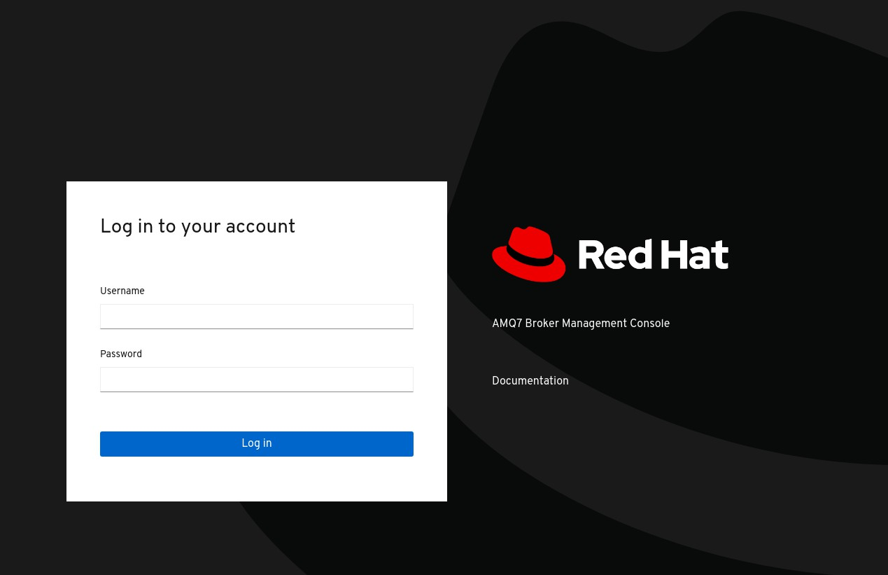

Log in to AMQ Management Console using the default user name and password that you created when you created the broker.

1. To connect to another, remote broker from the console session of the local broker:
   1. In the left menu, click the Connect tab.
   2. In the main pane, on the Remote tab, click the Add connection button.
   3. In the Add Connection dialog box, specify the following details:

Name

Name for the remote connection, for example, **my_other_broker**.

Scheme

Protocol to use for the remote connection. Select **http** for a non-secured connection, or

**https** for a secured connection.

Host

IP address of a remote broker. You must have already configured console access for this remote broker.

Port

Port on the local broker to use for the remote connection. Specify the port value that is defined for the **bind** attribute of the **web** element in the

***<broker_instance_dir>*/etc/bootstrap.xml** configuration file. The default value is **8161**.

Path

Path to use for console access. Specify **console/jolokia**.

* 1. To test the connection, click the Test Connection button.

If the connection test is successful, click the Add button. If the connection test fails, review and modify the connection details as needed. Test the connection again.

* 1. On the Remote page, for a connection that you have added, click the Connect button. A new web browser tab opens for the console instance on the remote broker.
  2. In the Log In dialog box, enter the user name and password for the remote broker. Click

Log In.

The console instance for the remote broker opens.

1. To connect to the console for the local broker from a remote host, specify the Jolokia endpoint for the local broker in a web browser. This endpoint includes the externally-reachable IP address that you specified for the local broker when configuring remote console access. For example:

[**http://192.168.0.49/console/jolokia**](http://192.168.0.49/console/jolokia)

#### Configuring AMQ Management Console to handle X-forwarded headers

Procedure

1. Open the ***<broker_instance_dir>*/etc/bootstrap.xml** file.
2. In the **<web>** element, add the **customizer** attribute with a value of

**org.eclipse.jetty.server.ForwardedRequestCustomizer**. For example:

**<web path="web" customizer="org.eclipse.jetty.server.ForwardedRequestCustomizer">**

**..**

**</web>**

1. Save the **bootstrap.xml** file.
2. Start or restart the broker by entering the following command:

On Linux: ***<broker_instance_dir>*/bin/artemis run**

On Windows: ***<broker_instance_dir>*\bin\artemis-service.exe start**



## MANAGING BROKERS USING AMQ MANAGEMENT CONSOLE

#### Viewing details about the broker

To see how the broker is configured, in the left menu, click Artemis. In the folder tree, the local broker is selected by default.

In the main pane, the following tabs are available:

**Status**

Displays information about the current status of the broker, such as uptime and cluster information. Also displays the amount of address memory that the broker is currently using. The graph shows this value as a proportion of the **global-max-size** configuration parameter.

Figure 4.2. Status tab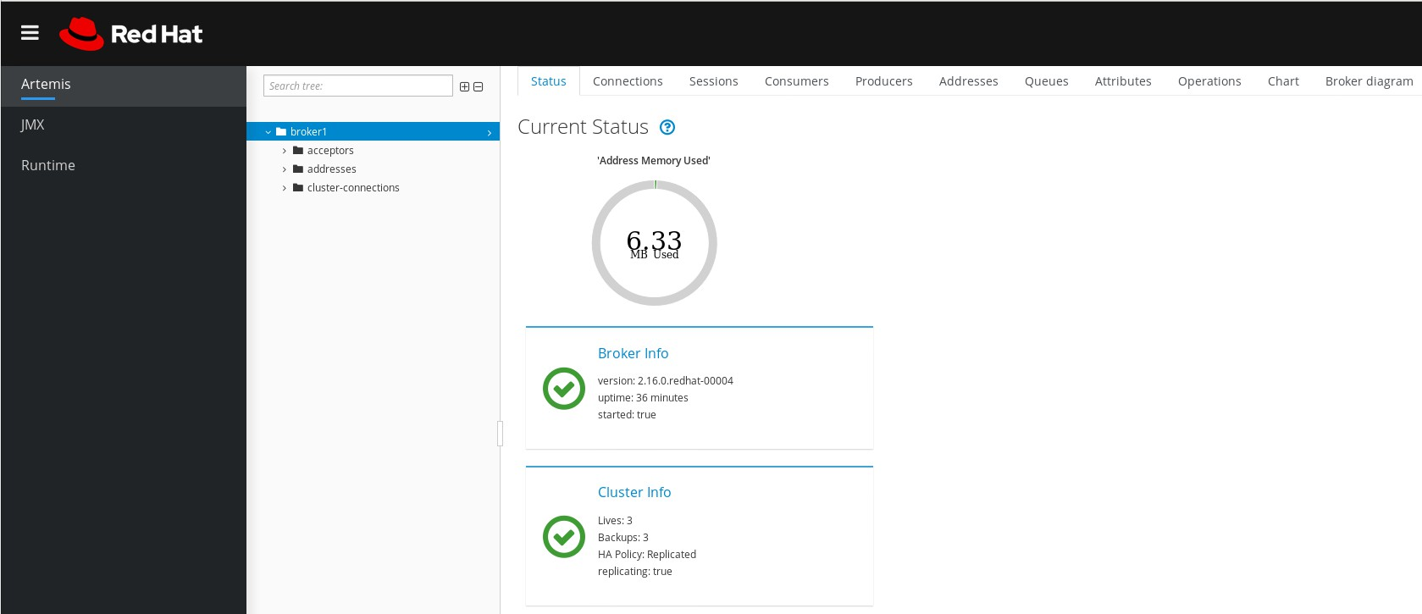

**Connections**

Displays information about broker connections, including client, cluster, and bridge connections.

**Sessions**

Displays information about all sessions currently open on the broker.

**Consumers**

Displays information about all consumers currently open on the broker.

**Producers**

Displays information about producers currently open on the broker.

**Addresses**

Displays information about addresses on the broker. This includes internal addresses, such as store- and-forward addresses.

**Queues**

Displays information about queues on the broker. This includes internal queues, such as store-and- forward queues.

**Attributes**

Displays detailed information about attributes configured on the broker.

**Operations**

Displays JMX operations that you can execute on the broker from the console. When you click an operation, a dialog box opens that enables you to specify parameter values for the operation.

**Chart**

Displays real-time data for attributes configured on the broker. You can edit the chart to specify the attributes that are included in the chart.

**Broker diagram**

Displays a diagram of the cluster topology. This includes all brokers in the cluster and any addresses and queues on the local broker.

#### Viewing the broker diagram

You can view a diagram of all AMQ Broker resources in your topology, including brokers (live and backup brokers), producers and consumers, addresses, and queues.

Procedure

1. In the left menu, click Artemis.
2. In the main pane, click the Broker diagram tab.

The console displays a diagram of the cluster topology. This includes all brokers in the cluster and any addresses and queues on the local broker, as shown in the figure.

Figure 4.3. Broker diagram tab

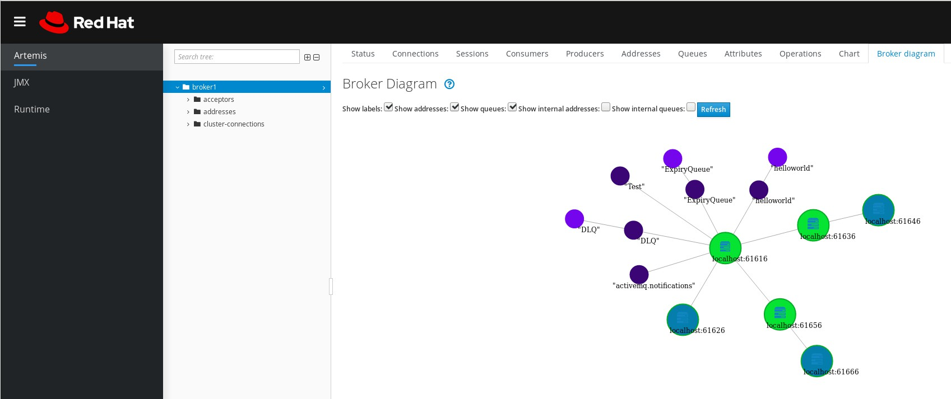

To change what items are displayed on the diagram, use the check boxes at the top of the diagram. Click Refresh.

1. To show attributes for the local broker or an address or queue that is connected to it, click that node in the diagram. For example, the following figure shows a diagram that also includes attributes for the local broker.

Figure 4.4. Broker diagram tab, including attributes

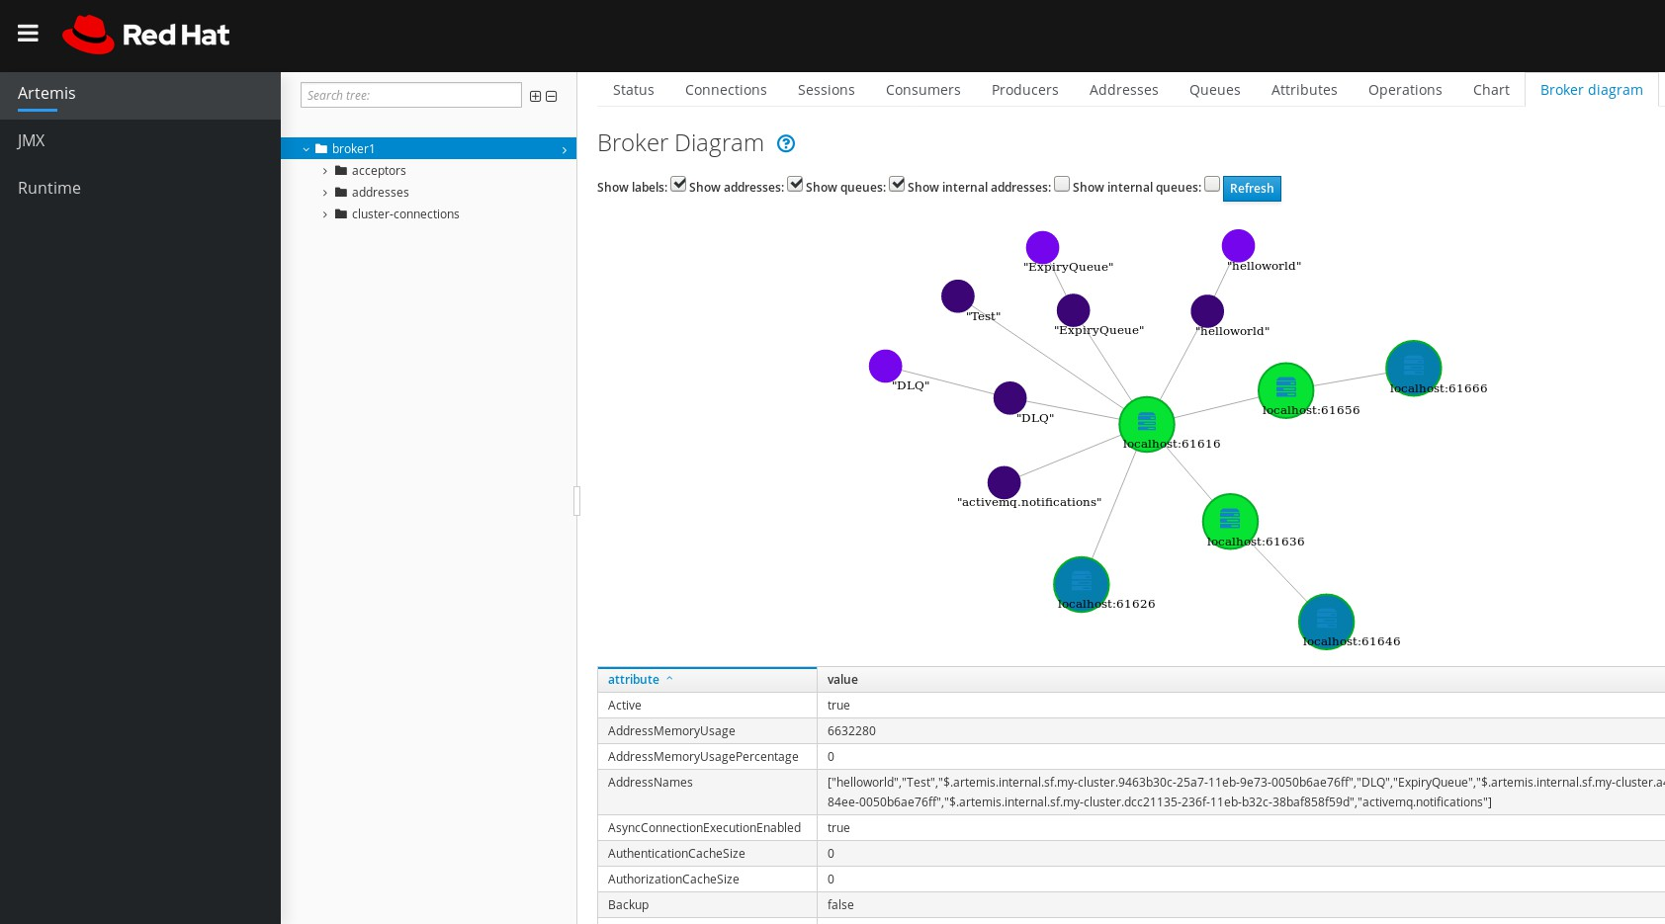

#### Viewing acceptors

You can view details about the acceptors configured for the broker.

Procedure

1. In the left menu, click Artemis.
2. In the folder tree, click acceptors.
3. To view details about how an acceptor is configured, click the acceptor.

The console shows the corresponding attributes on the Attributes tab, as shown in the figure.

Figure 4.5. AMQP acceptor attributes

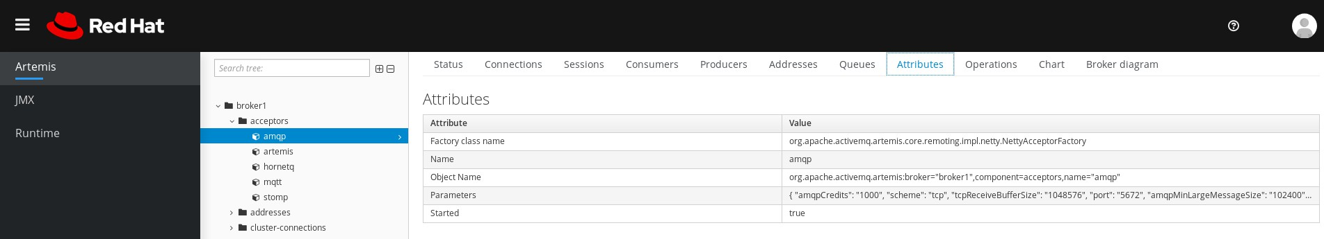

1. To see complete details for an attribute, click the attribute. An additional window opens to show the details.

#### Managing addresses and queues

###### Creating addresses

Procedure

* + - * 1. In the left menu, click Artemis.
        2. In the folder tree, click addresses.
        3. In the main pane, click the Create address tab.

A page appears for you to create an address, as shown in the figure.

Figure 4.6. Create Address page

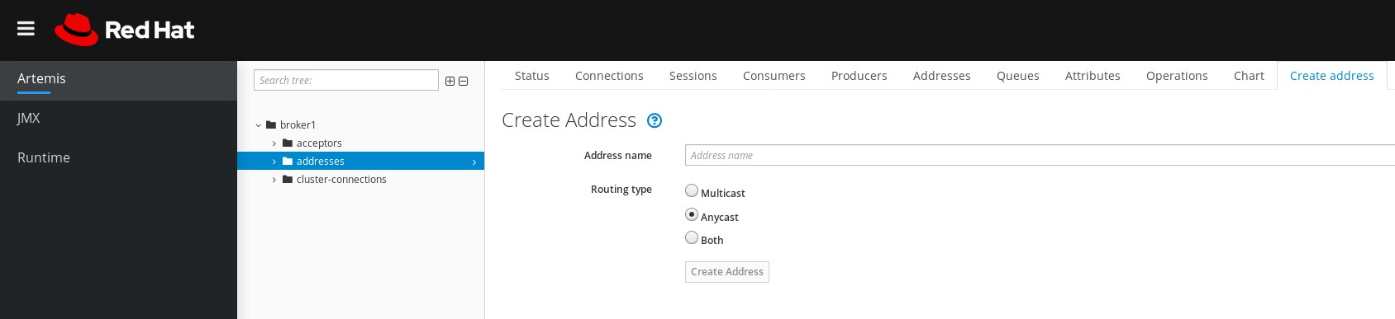

Complete the following fields:

**Address name**

The routing name of the address.

**Routing type**

Select one of the following options:

**Multicast**: Messages sent to the address will be distributed to all subscribers in a publish- subscribe manner.

**Anycast**: Messages sent to this address will be distributed to only one subscriber in a point-to-point manner.

**Both**: Enables you to define more than one routing type per address. This typically results in an anti-pattern and is not recommended.



* + - * 1. Click Create Address.

###### Sending messages to an address

Procedure

1. In the left menu, click Artemis.
2. In the folder tree, select an address.
3. On the navigation bar in the main pane, click More → Send message. A page appears for you to create a message, as shown in the figure.

Figure 4.7. Send Message page

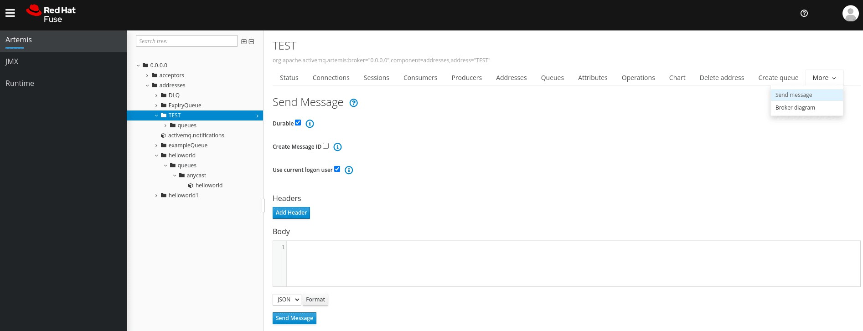

By default messages are sent using the credentials that you used to log in to AMQ Management Console. If you want to use different credentials, clear the Use current logon user checkbox

and specify values in the Username and Password fields, which are displayed after you clear the checkbox.

1. If necessary, click the Add Header button to add message header information.
2. Enter the message body.
3. In the Format drop-down menu, select an option for the format of the message body, and then click Format. The message body is formatted in a human-readable style for the format you selected.
4. Click Send message. The message is sent.
5. To send additional messages, change any of the information you entered, and then click Send message.

###### 

###### Creating queues

Procedure

* + - * 1. In the left menu, click Artemis.
        2. In the folder tree, select the address to which you want to bind the queue.
        3. In the main pane, click the Create queue tab.

A page appears for you to create a queue, as shown in the figure.

Figure 4.8. Create Queue page

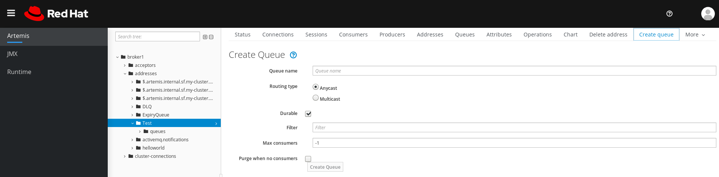

* + - * 1. Complete the following fields:

**Queue name**

A unique name for the queue.

**Routing type**

Select one of the following options:

**Multicast**: Messages sent to the parent address will be distributed to all queues bound to the address.

 **Anycast**: Only one queue bound to the parent address will receive a copy of the message. Messages will be distributed evenly among all of the queues bound to the address.

**Durable**

If you select this option, the queue and its messages will be persistent.

**Filter**

The username to be used when connecting to the broker.

**Max Consumers**

The maximum number of consumers that can access the queue at a given time.

**Purge when no consumers**

If selected, the queue will be purged when no consumers are connected.

* + - * 1. Click Create Queue.

###### Checking the status of a queue

Procedure

1. In the left menu, click Artemis.
2. In the folder tree, navigate to a queue.
3. In the main pane, click the Chart tab.

The console displays a chart that shows real-time data for all of the queue attributes.

Figure 4.9. Chart tab for a queue

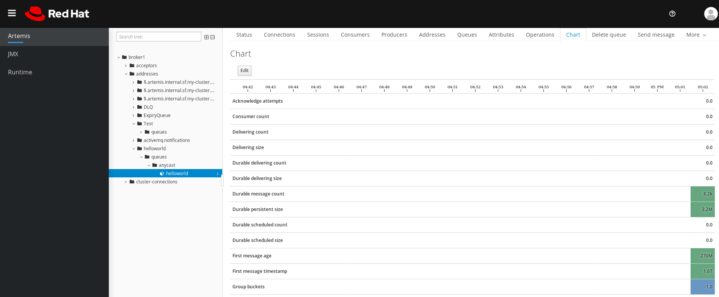

1. If necessary, select different criteria for the chart:

In the main pane, click Edit.

On the **Attributes** list, select one or more attributes that you want to include in the chart. To select multiple attributes, press and hold the Ctrl key and select each attribute.

Click the View Chart button. The chart is updated based on the attributes that you selected.

###### Browsing queues

Browsing a queue displays all of the messages in the queue. You can also filter and sort the list to find specific messages.

Procedure

1. In the left menu, click Artemis.
2. In the folder tree, navigate to a queue.

Queues are located within the addresses to which they are bound.

1. On the navigation bar in the main pane, click More → Browse queue.

The messages in the queue are displayed. By default, the first 200 messages are displayed.

Figure 4.10. Browse Queue page

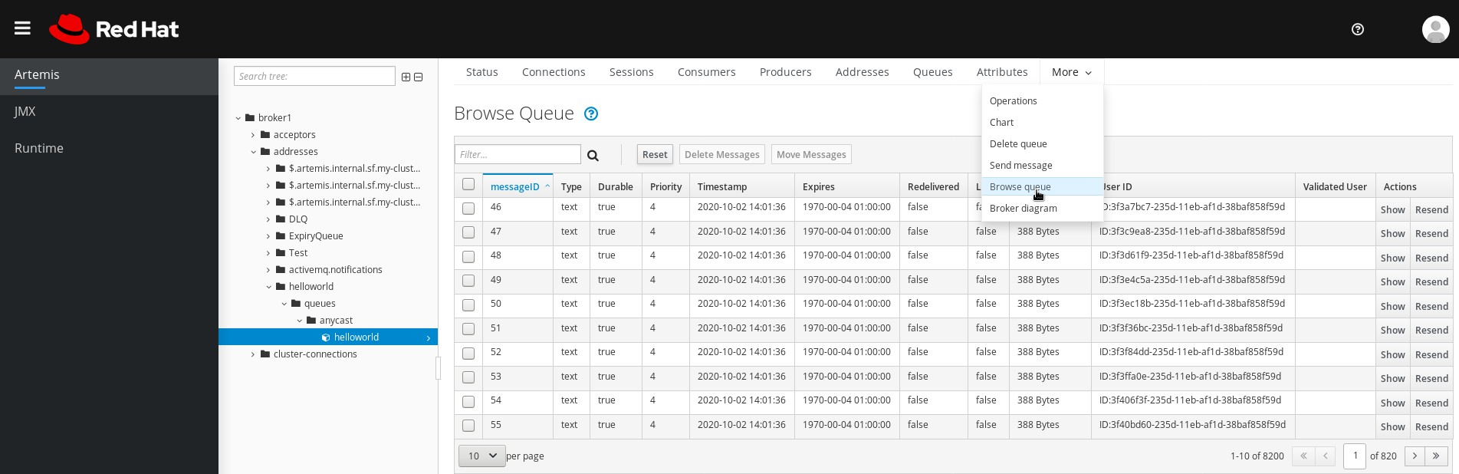

1. To browse for a specific message or group of messages, do one of the following:

|  |  |
| --- | --- |
| To… | Do this… |
| Filter the list of messages | In the **Filter…** text field, enter filter criteria. Click the search (that is, magnifying glass) icon. |
| Sort the list of messages | In the list of messages, click a column header. To sort the messages in descending order, click the header a second time. |

1. To view the content of a message, click the Show button. You can view the message header, properties, and body.

###### 

###### Sending messages to a queue

After creating a queue, you can send a message to it. The following procedure outlines the steps required to send a message to an existing queue.

Procedure

* + - * 1. In the left menu, click Artemis.
        2. In the folder tree, navigate to a queue.
        3. In the main pane, click the Send message tab.

A page appears for you to compose the message.

Figure 4.11. Send Message page for a queue

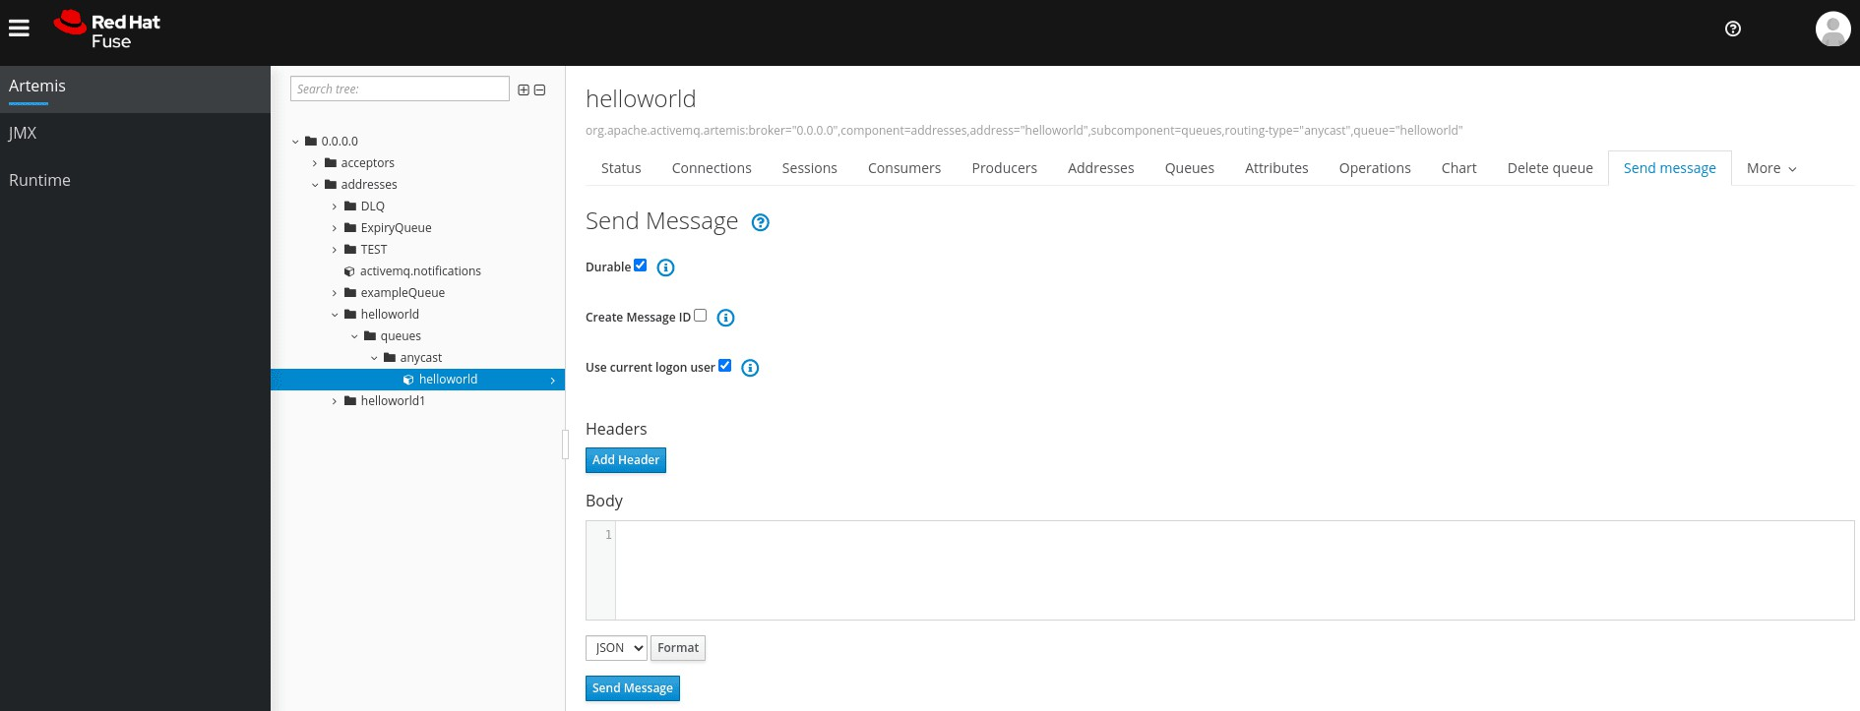

By default messages are sent using the credentials that you used to log in to AMQ Management Console. If you want to use different credentials, clear the Use current logon user checkbox

and specify values in the Username and Password fields, which are displayed after you clear the checkbox.

* + - * 1. If necessary, click the Add Header button to add message header information.
        2. Enter the message body.
        3. In the Format drop-down menu, select an option for the format of the message body, and then click Format. The message body is formatted in a human-readable style for the format you selected.
        4. Click Send message. The message is sent.
        5. To send additional messages, change any of the information you entered, and click Send message.

Resending messages to a queue

You can resend previously sent messages.

Procedure

1. Browse for the message you want to resend .
2. Click the check box next to the message that you want to resend.
3. Click the Resend button. The message is displayed.
4. Update the message header and body as needed, and then click Send message.

###### Moving messages to a different queue

You can move one or more messages in a queue to a different queue.

Procedure

* + - * 1. Browse for the messages you want to move .
        2. Click the check box next to each message that you want to move.
        3. In the navigation bar, click Move Messages. A confirmation dialog box appears.
        4. From the drop-down menu, select the name of the queue to which you want to move the messages. Click Move.

Deleting messages or queues

You can delete a queue or purge all of the messages from a queue.

Procedure

1. Browse for the queue you want to delete or purge .
2. Do one of the following:

|  |  |
| --- | --- |
| To… | Do this… |
| Delete a message from the queue | 1. Click the check box next to each message that you want to delete. 2. Click the Delete button. |
| Purge all messages from the queue | 1. On the navigation bar in the main pane, click Delete queue. 2. Click the Purge Queue button. |
| Delete the queue | 1. On the navigation bar in the main pane, click Delete queue. 2. Click the Delete Queue button. |